Colloquial Technical Terminology

🧾 What is Colloquial Technical Terminology
# Source: AI Source: Provided by: [Data Path: Persons Table -> ID Column: 1, Name_En Column: Motasem Essam] -> From: [Chatgpt (GPT-4-turbo)] on [7/31/2025]
Colloquial Technical Terminology refers to informal or slang-like versions of technical terms used within a professional or technical community, often for ease of communication or cultural familiarity.

✅ Key Features:
# Source: AI Source: Provided by: [Data Path: Persons Table -> ID Column: 1, Name_En Column: Motasem Essam] -> From: [Chatgpt (GPT-4-turbo)] on [7/31/2025]
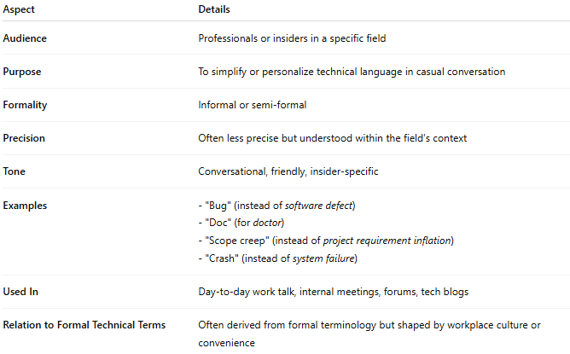
Aspect | Details
Audience | Professionals or insiders in a specific field
Purpose | To simplify or personalize technical language in casual conversation
Formality | Informal or semi-formal
Precision | Often less precise but understood within the field’s context
Tone | Conversational, friendly, insider-specific
Examples | - "Bug" (instead of software defect) - "Doc" (for doctor) - "Scope creep" (instead of project requirement inflation) - "Crash" (instead of system failure)
Used In | Day-to-day work talk, internal meetings, forums, tech blogs
Relation to Formal Technical Terms | Often derived from formal terminology but shaped by workplace culture or convenience

Colloquial Terminology vs Technical Terminology vs Lay Terminology:
# Source: AI Source: Provided by: [Data Path: Persons Table -> ID Column: 1, Name_En Column: Motasem Essam] -> From: [Chatgpt (GPT-4-turbo)] on [7/31/2025]
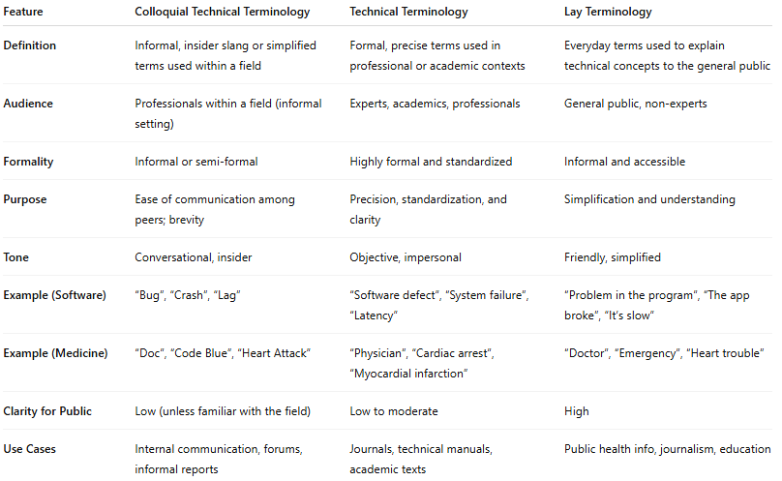
Feature | Colloquial Technical Terminology | Technical Terminology | Lay Terminology
Definition | Informal, insider slang or simplified terms used within a field | Formal, precise terms used in professional or academic contexts | Everyday terms used to explain technical concepts to the general public
Audience | Professionals within a field (informal setting) | Experts, academics, professionals | General public, non-experts
Formality | Informal or semi-formal | Highly formal and standardized | Informal and accessible
Purpose | Ease of communication among peers; brevity | Precision, standardization, and clarity | Simplification and understanding
Tone | Conversational, insider | Objective, impersonal | Friendly, simplified
Example (Software) | “Bug”, “Crash”, “Lag” | “Software defect”, “System failure”, “Latency” | “Problem in the program”, “The app broke”, “It’s slow”
Example (Medicine) | “Doc”, “Code Blue”, “Heart Attack” | “Physician”, “Cardiac arrest”, “Myocardial infarction” | “Doctor”, “Emergency”, “Heart trouble”
Clarity for Public | Low (unless familiar with the field) | Low to moderate | High
Use Cases | Internal communication, forums, informal reports | Journals, technical manuals, academic texts | Public health info, journalism, education

🧠 Summary:
# Source: AI Source: Provided by: [Data Path: Persons Table -> ID Column: 1, Name_En Column: Motasem Essam] -> From: [Chatgpt (GPT-4-turbo)] on [7/31/2025]
Colloquial technical terminology blends professional knowledge with informal tone, helping experts communicate more naturally within their own circles. While not always suitable for formal writing or public communication, it’s effective in team settings and peer discussions.

